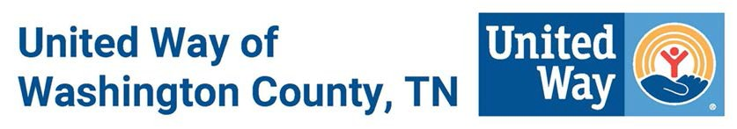

COVID-19 RESPONSE FUND APPLICATION

All completed applications should be emailed to Kristan Spear, kspear@uwowc.org and copy Leslie Salling, lsalling@uwowc.org.

If you are not a United Way of Washington County TN Program Partner, please attach the following to your application:

__ IRS 501(c)(3) Verification
__ Charitable Solicitation Letter
__ List of Board of Directors
Please respond to the following questions:

AGENCY NAME: ___________________________________________________________________

NAME AND TITLE (Program Contact): __________________________________________________

PHONE: ________________________ EMAIL: _________________________

- Mark which category your program addresses (You can mark multiple categories)

HEALTH FINANCIAL STABILITY EDUCATION

- Briefly describe the program. (Attach additional page, if needed).

- Is this a new program meeting needs unique to Coronavirus disease 2019 (COVID-19) or is this program already in place and adjusted to meet needs related to Coronavirus disease 2019 (COVID-19)?

- Please indicate how much assistance you believe your program needs, what specifically, it will be used for and how many people in Washington County will benefit.

Thank you for your ongoing commitment to the citizens of Washington County TN!

(423) 220-1229 • www.uwowc.org

